Name :- Vedang P. Gadge
Roll No:- 2601058
Division:- (A)
- Write a program to read a file and count how many vowels are present in its content.
Code:-
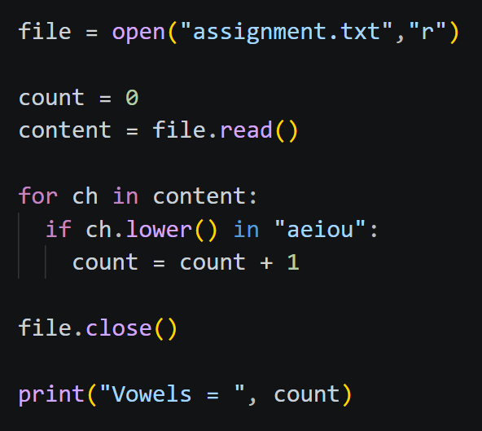
Output:-
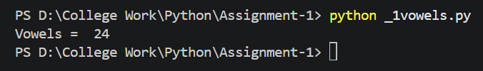

- Read all lines from a file into a list. Print the total number of lines and display the 2nd and 4th line.

Code:-
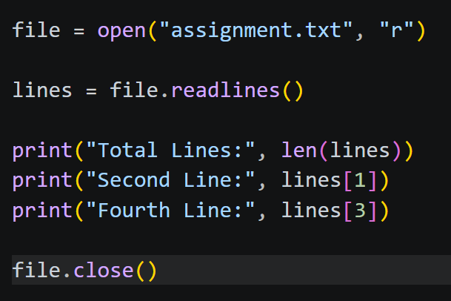

Output:-

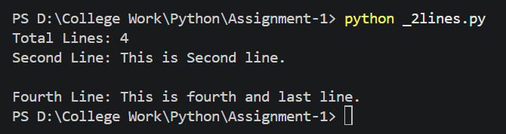

- Take a sentence from the user, split it into words, and store them in a list. Print the longest word.

Code:-

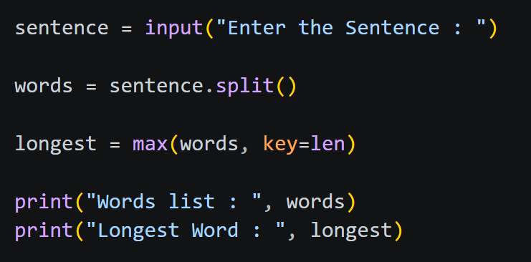

Output:-
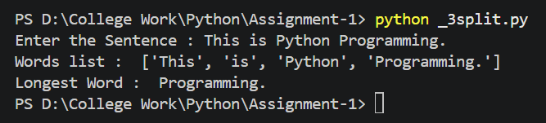

- Read a file, split its content into words, and store them in a list.
    - Print the total number of words.
    - Print all unique words.
Code:-
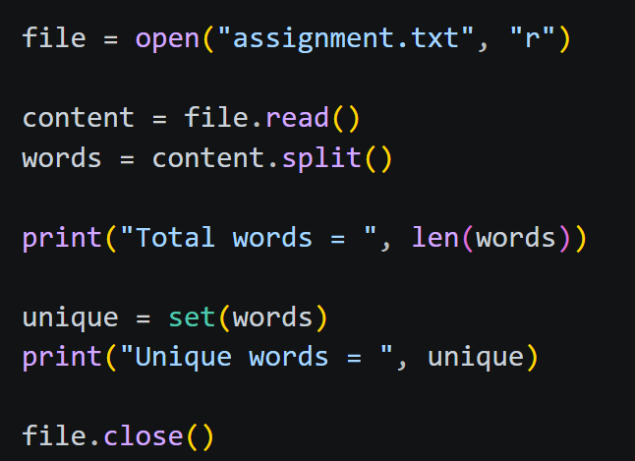

Output:-
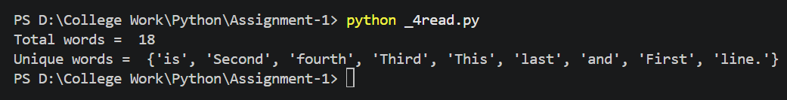
Txt file:-
